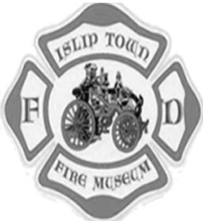
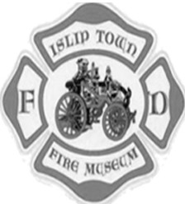
Islip Town Fire/EMS Museum
Online Firefighter Seminar
October 22, 2020 7pm to 9pm

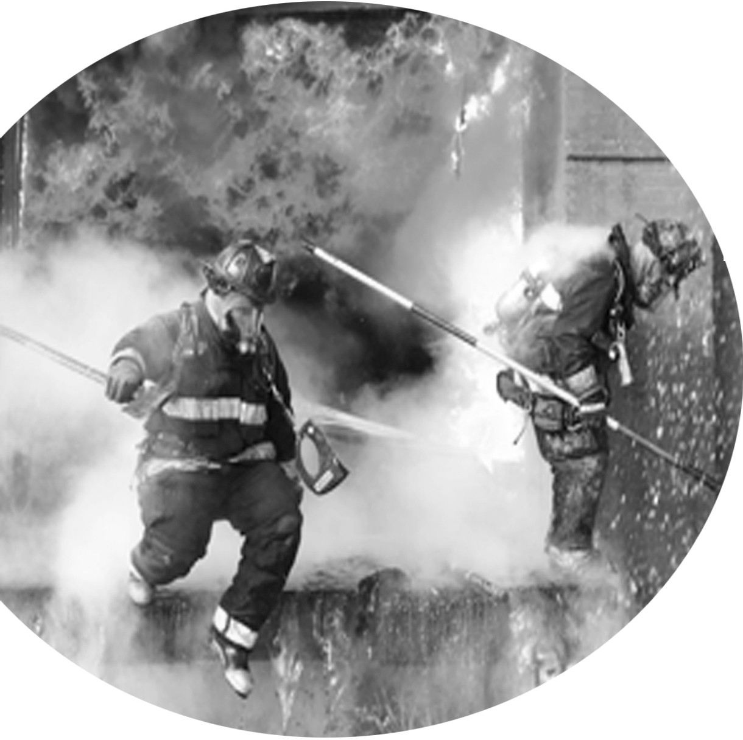
This class will cover:
Problems confronted by Firefighters and officers at fires everyday Problems that endangered them and their team

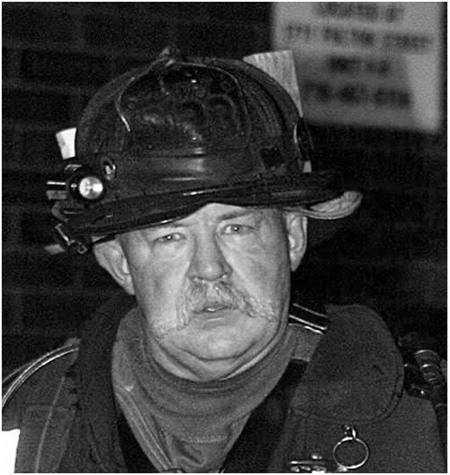
Common problems and how they affect team safety and fire operations How we can predict them, avoid them or lessen their impact

Michael M. Dugan
FDNY Firefighter

44-year veteran of the fire service 27-year veteran of the FDNY
Received the James Gordon Bennett medal in 1992
Harry M. Archer Medal in 1993, FDNY's highest award for bravery Editor at Fire Engineering Magazine
Teacher at Fire Department Instructor Conference (FDIC) Fire Engineering and FDIC Executive Board member

Click here to Register

(631) 778-6621 (leave a message)$25Per Attendee 4 Court House Drive
Central Islip, NY

